**FUNCTIONAL AND TECHNICAL COMBINED DOCUMENTATION**

**Page (10): Portfolio Alerts (Front End Url:** http://localhost:8100/page10/Page10)

**Functional Picture:**

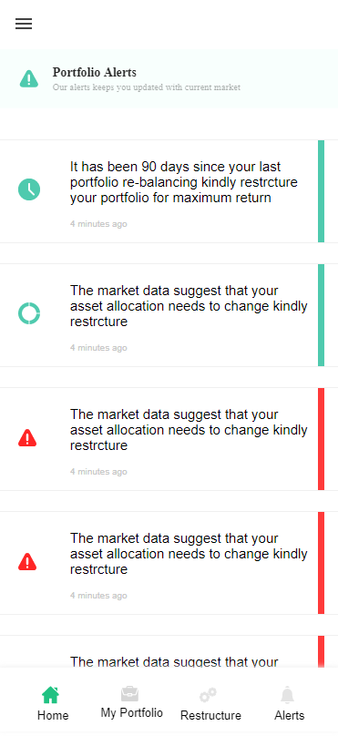

**In this Page, the user is going to see the list of portfolio alerts.**

Rebalancing Ninety Day Alert

Portfolio Alert when Asset Allocation Table is Updated.

Portfolio Alert when Equity Allocation Table is Updated.

Portfolio Alert Asset Increased Significantly (by 10%)

Portfolio Alert Asset Decreased Significantly (by 10%)

Portfolio Alert Market Cap Increased Significantly

Portfolio Alert Market Cap Increased Significantly

**Technical Explanation (Front End and Back End):**

**In Page10.tsx, we are calling following 7 API’s:**

1. RebalancingNinetyDayAlert: see backend python file. In this we are doing GET requests.
2. PortfolioAlertAssetAllocationUpdateAPI: see backend python file. In this we are doing GET requests.
3. PortfolioAlertEquityAllocationUpdateAPI: see backend python file. In this we are doing GET requests.
4. PortfolioAlertAssetIncreasedSignificantlyAP: see backend python file. In this we are doing GET requests.
5. PortfolioAlertAssetDecreasedSignificantlyAPI: see backend python file. In this we are doing GET requests.
6. PortfolioAlertMarketCapIncreasedSignificantlyAPI: see backend python file. In this we are doing GET requests.
7. PortfolioAlertMarketCapDecreasedSignificantlyAPI: see backend python file. In this we are doing GET requests.

RebalancingNinetyDayAlert: see backend python file. In this we are doing GET requests.

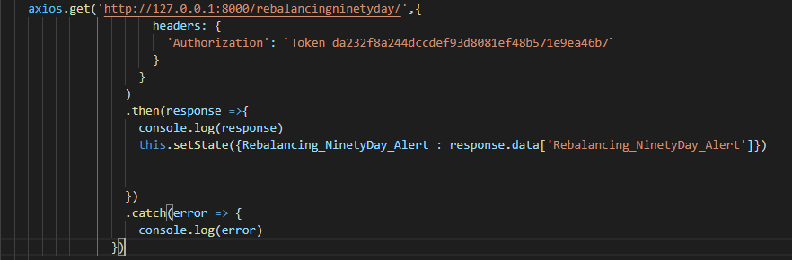

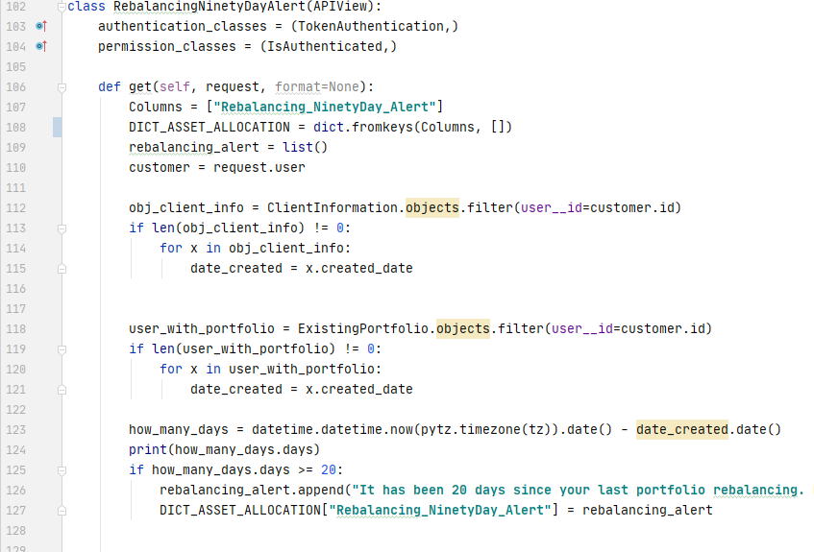

**The above code is self-explanatory. First we are check what is the type of the user: 1) User without existing Portfolio 2) User with existing portfolio. Accordingly, with the help of their respective databases, we are taking the date at which the user on boarded and we are subtracting that date with today’s date and then we are checking if it’s been 90 days and the user has not rebalanced his portfolio then we will give him the alert. (For testing purpose we have used 20 days)**

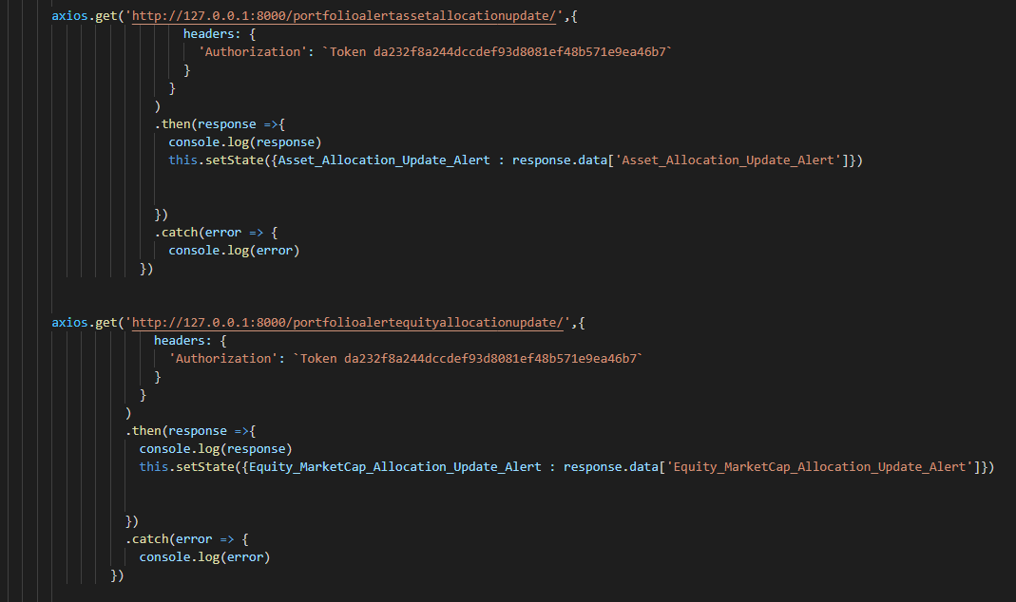

**The above two API calling will trigger the portfolio alert if the admin has changed the Asset Allocation and Equity Allocation Table parameter values. Please see the** PortfolioAlertAssetAllocationUpdateAPI and PortfolioAlertEquityAllocationUpdateAPI in the backend code(PortfolioAlert.py).

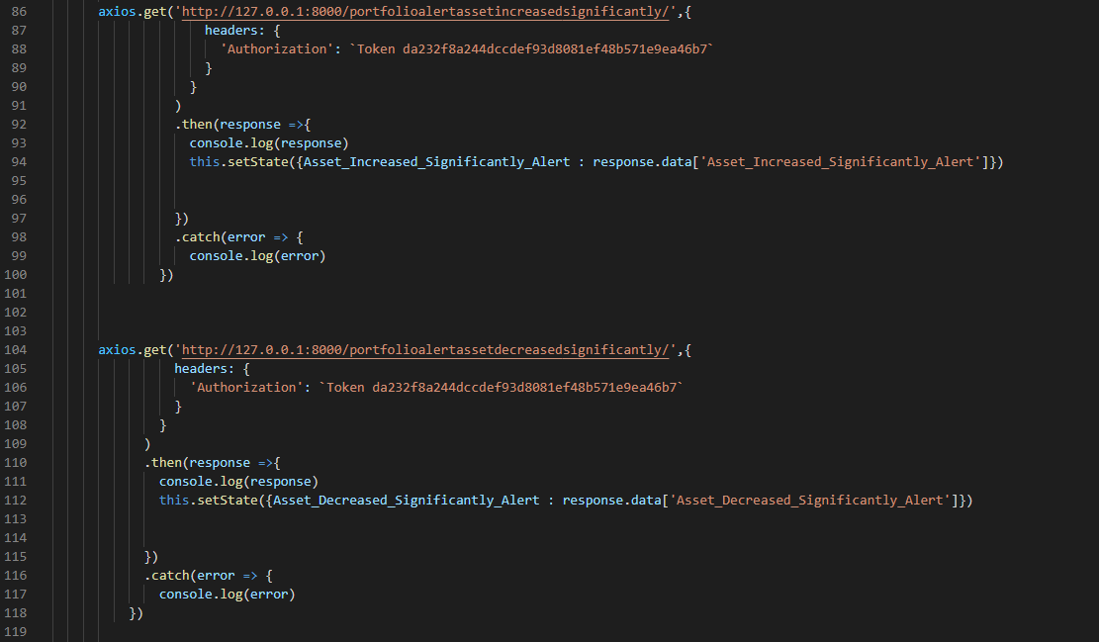

**The above two API calling will trigger the portfolio alert if the assets has increased or decreased by 10%. Please see the** PortfolioAlertAssetIncreasedSignificantlyAPI and PortfolioAlertAssetDecreasedSignificantlyAPI in the backend code(PortfolioAlert.py).

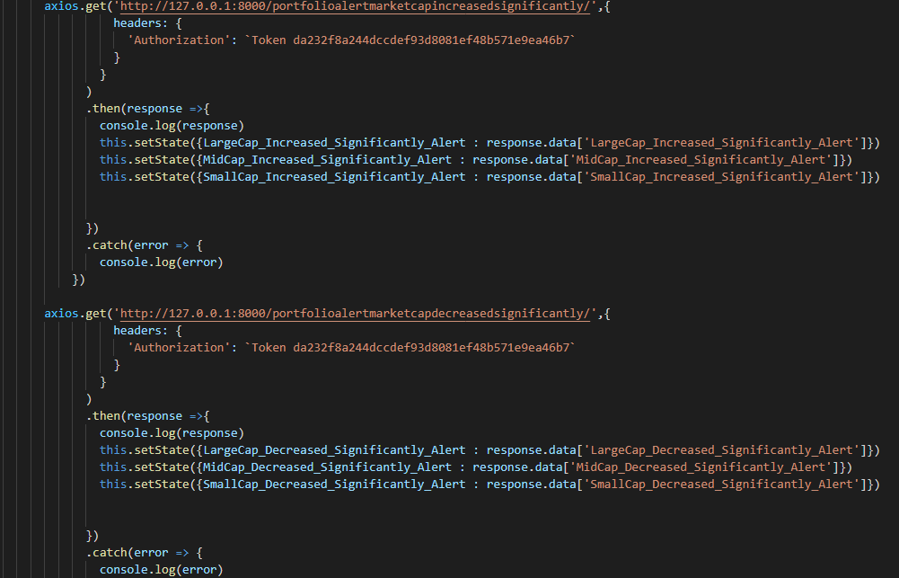

**The above two API calling will trigger the portfolio alert if the particular market cap has increased or decreased by 10%. Please see the** PortfolioAlertMarketCapIncreasedSignificantlyAPI and PortfolioAlertMarketCapDecreasedSignificantlyAPI in the backend code(PortfolioAlert.py).

DONE !!!